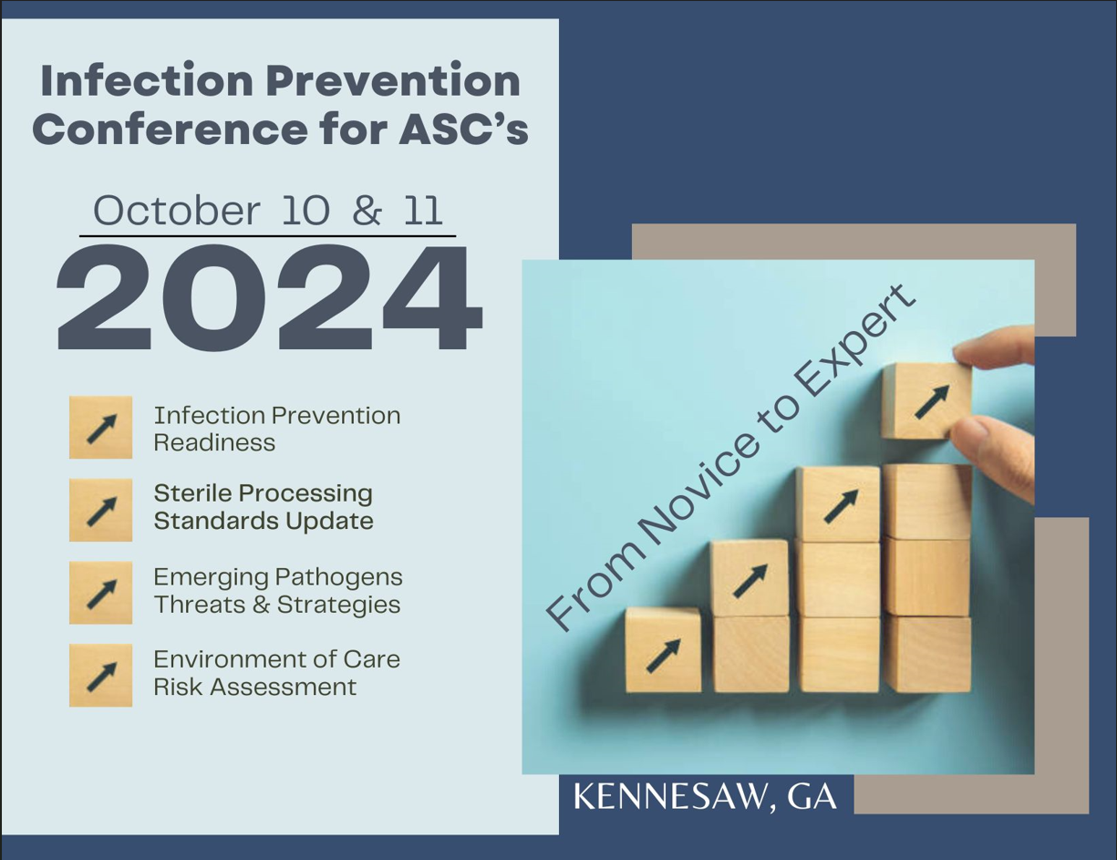

**Infection Prevention Conference**

**From Novice to Expert**

**October 10th & 11th, 2024**

**Presented by:**



1275 Shiloh Road, Suite 3010

Kennesaw, GA 30144

770-794-4944

**Infection Prevention Conference**

**From Novice to Expert**

**October 10-11, 2024**

Criteria for successful completion

Attendance at each session and completion of the online evaluation survey. The evaluation form will be emailed to each participant within two weeks following the conference; once evaluation form is completed, certificates will be emailed.

Conflict of Interest

There is no conflict of interest for anyone with the ability to control content for these sessions of this activity.

Continuing Education Disclosure:

This program is approved for up to 12.0 hours of AEUs and up to 12.0 hours of IPCHs by BASC Provider # 4309. The content areas may be claimed for CASC or CAIP recertification.

Provider approved by the California Board of Registered Nursing, Provider Number 17359 for 12.0 contact hours

**Infection Prevention Conference**

**From Novice to Expert**

**October 10-11, 2024**

**Day One– Thursday, October 10, 2024 7:00 am – 5:00 pm**

7:00 – 7:30 *Registration*

7:30 – 7:45 **Welcome and Introduction**

Gayle Evans, RN, MBA, CNOR, CASC President,

Continuum Healthcare Consultants, Inc.

7:45 – 9:00 ***ABC’s of Surgical Site Infections***

Gayle Evans, RN, MBA, CNOR, CASC President,

Continuum Healthcare Consultants, Inc.

9:00 – 9:30 *Coffee Break/Visit Exhibits*

9:30 – 11:00 ***Have Bug, Will Travel:***

***Pathways to Infection Prevention in Your Facility***

Wava Truscott, Truscott MedSci Associates, LLC. PhD, MBA

11:00 – 12:00 ***Water Quality***

Arthur Henderson, *STERIS*, RN, BA, CNOR, CRCST, CHL, ASQ-CQIA, GTS

*12:00 – 1:00 Lunch & Visit Exhibits*

1:00-2:15 ***Instrument Handling***

Arthur Henderson, *STERIS*, RN, BA, CNOR, CRCST, CHL, ASQ-CQIA, GTS

2:15-3:15 ***Sterilization Quality Control for the ASC***

Michelle Keenan, *Solventum,* BS, CSPDT

3:15-3:30 Break/Visit Exhibits

3:30-4:45 **Round Table Discussions –**

**Live Discussions from Our Panel of Speakers**

**Infection Prevention Conference**

**From Novice to Expert**

**October 10-11, 2024**

**Day Two– Friday, October 11, 2024 7:00 am – 1:00pm**

7:00 – 7:15 *Registration*

7:30 – 8:45 ***Importance of IFU’s:***

***Guidelines & Policies***

Faith E. Wheeler, MBA, BSN, RN, CNOR

8:45-10:15 ***Interim Life Safety and Infection Prevention***

Milli Duncan, *LDD Blueline,* RID, IIDA, LEED AP, NCIDQ

10:15-10:30 *Break/Check out*

10:30-11:30 ***More Than Compliance:***

***Keeping Staff Safe from Sharps Injuries***

Amanda Heitmen, *Qlicksmart,* BSN, RN, CNOR

11:30 –12:30 ***OSHA- Caring for Your Employees***

Faith E. Wheeler, MBA, BSN, RN, CNOR

12:30 – 12:45 **Closing Remarks**