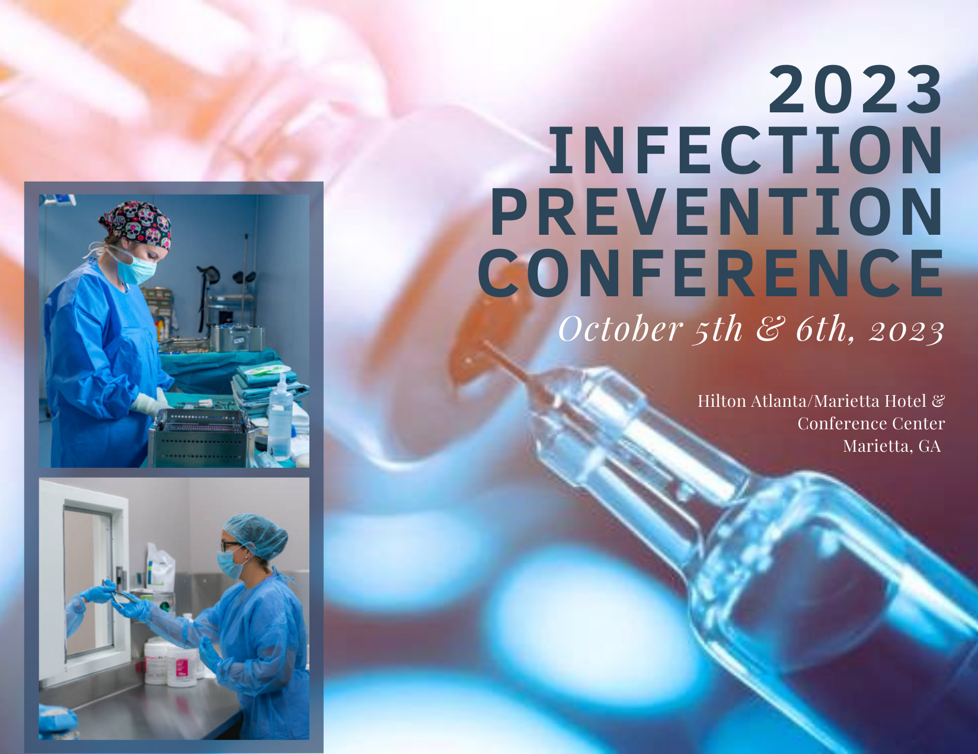

**Infection Prevention Conference**

**October 5th & 6th, 2023**

**Presented by:**



1275 Shiloh Road, Suite 3010

Kennesaw, GA 30144

770-794-4944

**Infection Prevention Conference**

**October 5-6, 2023**

**Day One– Thursday, October 5, 2023 7:00 am – 5:00 pm**

7:00 – 7:30 *Registration*

7:30 – 8:00 **Welcome and Introduction**

Gayle Evans, RN, MBA, CNOR, CASC President,

Continuum Healthcare Consultants, Inc.

8:00 – 9:15 ***Competency Related to the Infection Preventionist***

Faith E. Wheeler, MBA, BSN, RN, CNOR

9:15 – 9:45 *Coffee Break/Visit Exhibits*

9:45 – 10:45 ***The Wipe on the Wall***

Sharon Ward-Fore, BS, MS, MT(ASCP), CIC, FAPIC

*Metrex-Infection Prevention Advisor*

10:45 – 11:45 ***Improve Your PPE Compliance:***

***Are we using the Proper Protection?***

Penny Steele, *Cardinal Health*, RN, CNOR, CCSVP

*11:45 – 12:45 Lunch & Visit Exhibits*

12:45-2:00 ***Point of Use Treatment: Where Successful Processing Begins***

Arthur Henderson, *STERIS*, RN, BA, CNOR, CRCST, CHL, ASQ-CQIA, GTS

2:00-2:15 Break/Visit Exhibits

2:15-3:45 ***What do you mean I Caused that Post-Surgical Complication?***

Wava Truscott, Truscott MedSci Associates, LLC. PhD, MBA

3:45-5:00 **Round Table Discussions –**

**Live Discussions from Our Panel of Speakers**

**Infection Prevention Conference**

**October 5-6, 2023**

**Day Two– Friday, October 6, 2023 7:00 am – 1:00pm**

7:00 – 7:15 *Registration*

7:15 – 8:30 ***Optimizing the Perioperative Journey***

Christopher J. Hudgins, *3M*, BSN, ASN, RN, CNOR

8:30-10:00 ***Infection Prevention/QI/Benchmarking***

Faith E. Wheeler, MBA, BSN, RN, CNOR

10:00-10:30 *Break/Check out*

10:30-11:30 ***Choosing the Right Skin Antiseptic***

Daniel Pascal, *BD Surgical*, BSN, RN

11:30 –12:30 ***Is it Clean?***

Arthur Henderson, *STERIS*, RN, BA, CNOR, CRCST, CHL, ASQ-CQIA, GTS

12:30 – 12:45 **Closing Remarks**

**Infection Prevention Conference**

**October 5-6, 2023**

Criteria for successful completion

Attendance at each session and completion of the online evaluation survey. The evaluation form will be emailed to each participant within two weeks following the conference; once evaluation form is completed, certificates will be emailed.

Conflict of Interest

There is no conflict of interest for anyone with the ability to control content for these sessions of this activity.

Continuing Education Disclosure:

This program is approved for up to 12.0 hours of AEUs and up to 12.0 hours of IPCHs by BASC Provider # 4309. The content areas may be claimed for CASC or CAIP recertification.

Provider approved by the California Board of Registered Nursing, Provider Number 17359 for 12.0 contact hours